STUDENT MANAGEMENT SYSTEM MOBILE APPLICATION DOCUMENTATION
Name: Virginia Munyori
Admission Number: BIT/2025/67506
Unit Code: BIT4107
Unit Name: Mobile Applications Development
1. Introduction
The Student Management System is a Flutter-based mobile application designed to manage student information digitally. The application allows users to register, log in, add students, view student records, and store information permanently using a SQLite database.
The system solves the problem of manual student record management by providing an organized and reliable mobile platform.
2. Project Objectives
The objectives of the application are:
To develop a mobile application for managing student information.
To implement user authentication.
To store student records permanently.
To perform database operations using SQLite.
To demonstrate CRUD operations.
To manage student information efficiently.
3. Technologies Used
Flutter
Flutter was used to design and develop the mobile application interface.
Dart Programming Language
Dart was used to implement application logic.
SQLite Database
SQLite was used for local data storage because it is lightweight and supports offline storage.
Packages Used
sqflite - database operations
path - database file location
crypto - password hashing
4. System Features
User Authentication
The application provides:
User registration
User login
Password encryption
Users must create an account before accessing the dashboard
Student Management
The application allows users to:
Add student records
View student details
Store student information
Student details include:
Name
Email
Course
Year of Study
Phone Number
5. Database Design
Users Table
Field
Type
id
Integer Primary Key
email
Text
password
Text
Students Table
Field
Type
id
Integer Primary Key
name
Text
email
Text
course
Text
year
Text
phone
Text
Attendance Table
Field
Type
id
Integer Primary Key
studentId
Integer
date
Text
status
Text
6. Database Operations (CRUD)
The system supports:
Create
Adding new users and students.
Read
Displaying saved student records.
Update
Modifying student information.
Delete
Removing records from the database.

Screenshots
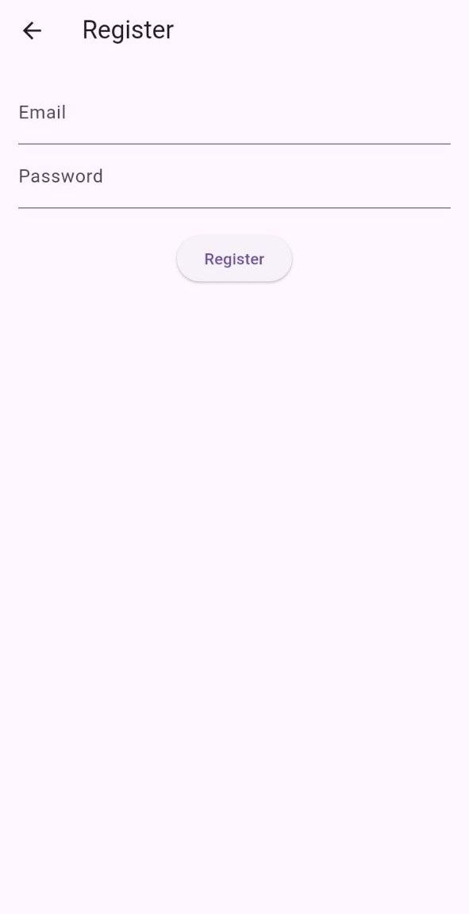
Registration Screen – Register details
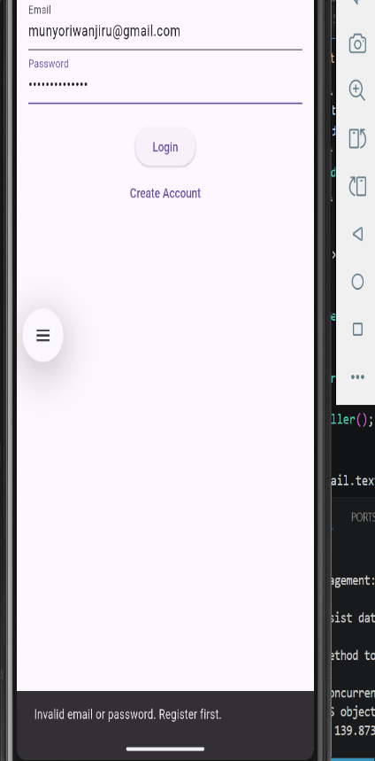

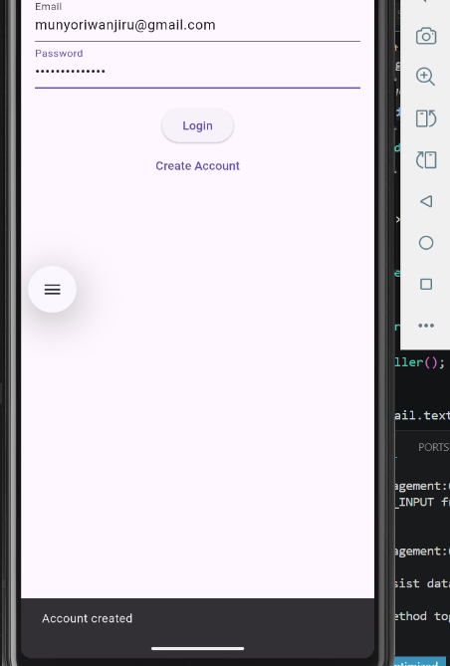
Login Screen – Enter you details
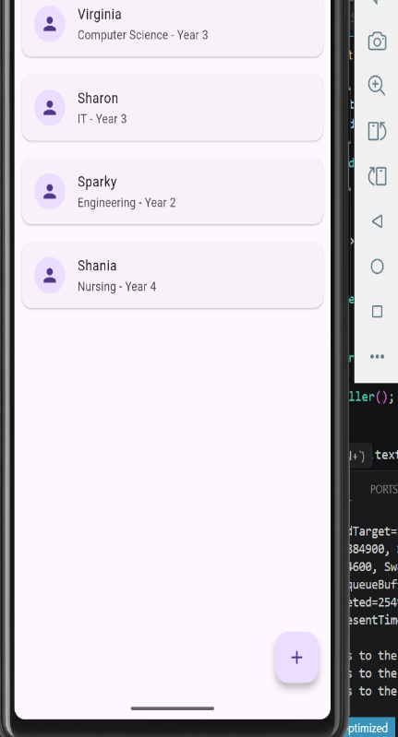
Student Records – Records of student dedails
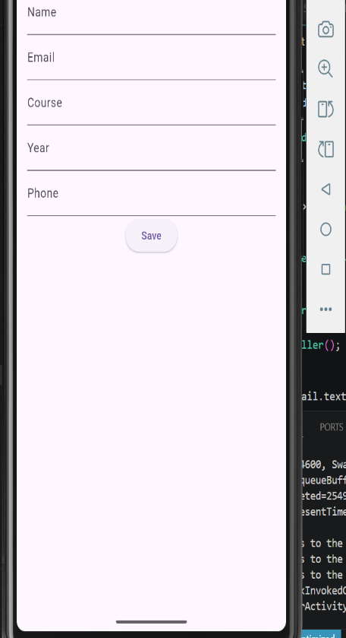
Add Student – Add student records
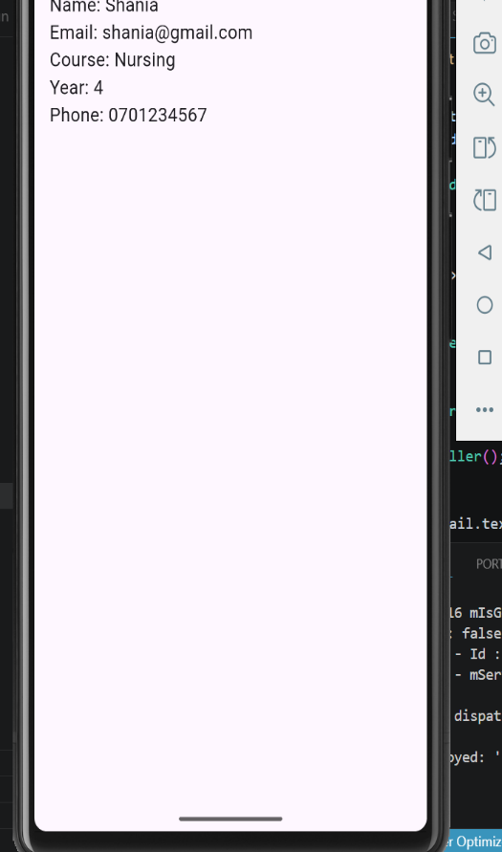
Student Profile – Saved student records

7. Application Flow
User Registration
↓
Login
↓
Dashboard
↓
Add Student
↓
Save to SQLite Database
↓
Display Student Records
8. Networking Concept Implementation
The application follows mobile networking concepts:
Client:
Flutter mobile application
Server:
Remote database/API concept
Data Format:
JSON format
9. Security
Passwords are not stored directly.
The application uses hashing before storing passwords in the database.
10. Conclusion
The Student Management System successfully demonstrates mobile application development concepts including user authentication, database integration, CRUD operations, and data storage using Flutter and SQLite.

Logbook -
Student Management System Mobile Application
Week 7
Technology Used:
Flutter
Dart
SQLite Database
Android Emulator
VS Code / Android Studio
Project Introduction and Planning
Activities Done:
Identified the need for a student management application.
Defined the purpose of the system.
Planned the main features of the application.
Created the Flutter project.
Work Completed:
Project environment was prepared.
Application requirements were identified.
Challenges:
Understanding the project structure.
Solution:
Studied Flutter folder organization and application flow.
User Interface Development
Activities Done:
Designed the login screen.
Designed registration screen.
Created dashboard interface.
Added navigation between screens.
Work Completed:
Created:
Login page
Registration page
Dashboard page
Challenges:
Connecting screens correctly.
Solution:
Used Flutter routes and Navigator.
Authentication Implementation
Activities Done:
Developed user registration functionality.
Developed login functionality.
Added email and password input fields.
Work Completed:
Users can create accounts.
Users can access the dashboard after login.
Challenges:
Login was allowing access without checking users.
Solution:
Connected authentication with database.
Database Design and Implementation
Activities Done:
Added SQLite database.
Created database helper class.
Designed database tables.
Database Tables Created:
Users Table
Stores:
User ID
Email
Password
Students Table
Stores:
Student ID
Name
Email
Course
Year
Phone
Student Management Module
Activities Done:
Created student model.
Created Add Student screen.
Connected dashboard with database.
Work Completed:
Implemented:
Adding students
Viewing students
Displaying student profiles
Challenges:
Data was disappearing after closing the app.
Solution:
Replaced temporary list storage with SQLite.
Security and Testing
Activities Done:
Added password hashing.
Tested registration and login.
Tested database storage.
Fixed application errors.
Work Completed:
Passwords are stored securely.
User authentication works.
Student records are saved permanently.
Challenges:
Import errors and file organization issues.
Solution:
Organized project folders:
models
database
screens
Testing and Documentation
Activities Done:
Tested complete application flow.
Testing:
Login
↓
Dashboard
↓
Add Student
↓
Save Data
↓
View Student Records
Final Improvements:
Improved navigation.
Fixed errors.
Prepared documentation.
Project Outcome
The Student Management System application was successfully developed with:
User registration
Login authentication
Password hashing
SQLite database
Student records management
Organized Flutter structure
Conclusion
The project provided practical experience in Flutter mobile development, database integration, authentication, and application testing. The final system demonstrates how mobile applications can be used to manage student information efficiently

